Pet Bird GPS Tracking Devices
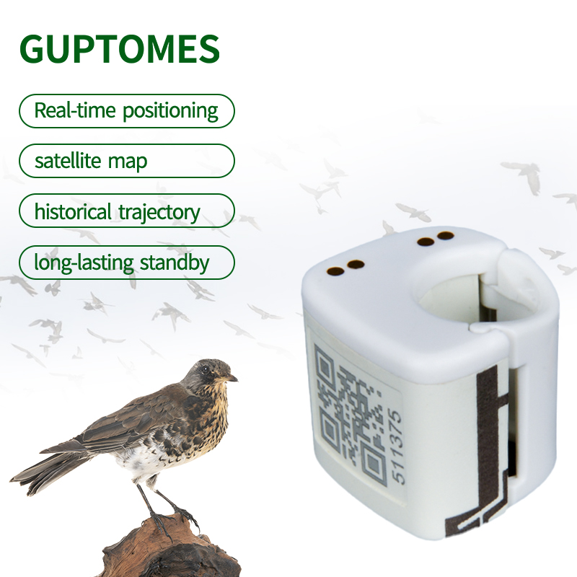
Price：$54.3
Product model：V11
Product parameter：
Positioning Mode | GPS + LBS
Network | 2G
Charging Method | Charging dock + Type-C
Positioning Accuracy | 5–15 meters
Waterproof Rating | Daily waterproof
Battery Life | 24–48 hours (tracking every 12 hours)
Battery Capacity | 80mAh
Dimensions | 20 × 20 × 20 mm
Weight | 5.4g
Product feature：
• Real-time GPS Tracking: Offers real-time positioning with unlimited range using a 2G signal.
• Small and Secure Design: The tracker is small in size and designed to be secure, so it's not easy to drop.
• Durable and Waterproof: The device is described as "Watertight" and has IP67 waterproof certification.
• Long Standby Time: The tracker has a long battery life.
• Quality and Safety: The product is designed to be "Safe by design" with quality assurance, backed by various certifications (CE, FCC, SGS).
• Multi-Species Applicability: The tracker can be used on a variety of pet birds, including pigeons, parrots, and other small birds.
• Compact and Convenient: The complete product set includes a tracker, a charging base, a charging cable, and instructions.
Product function：
• Real-time and Historical Trajectory: Allows you to view your bird's current location and analyze its historical flight path.
• Training and Analysis: Provides features like a built-in map, trajectory analysis, and training records to help with bird training.
• Privacy Protection: The system is built with privacy protection in mind.
• Electronic Fence: You can set up an electronic fence or geofence to get alerts if the bird leaves a designated area.
• Remote Viewing: You can view the tracker's data by downloading the software and logging in with your account.
• Multi-Unit Tracking: The system allows you to view multiple trackers at the same time on a single map.

